# Application Testing

### Contributors

SHOAIB AHMED, 17b-033-se@students.uit.edu, Usman Institute of Technology.

## **Screen Containers**

In this application we have 2 screen containers

### Navigation container

This container used for navigation of different pages in our application.

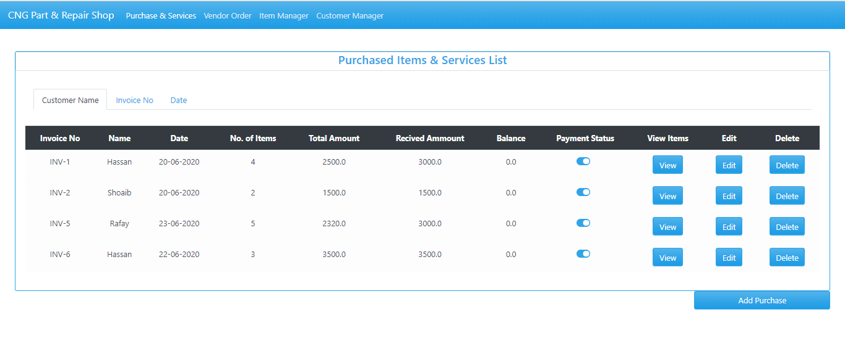

### View container

This container is used for to view the detail of the customer ,item, vendors etc

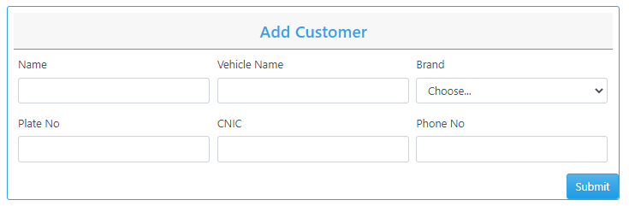

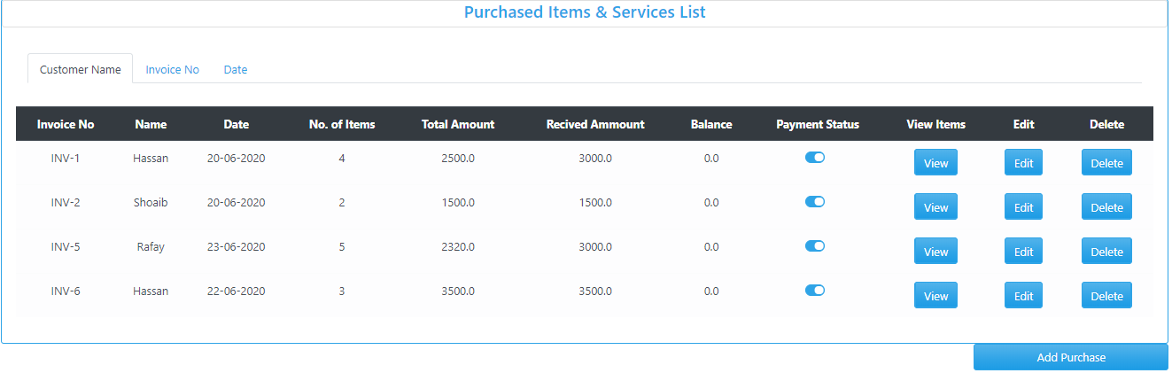

## **Element selection**

In our application we have 6 types of element selection

### Text Box

Figure 1: Textbox for alpha value

Figure 2: Read-Only Textbox for alphanumeric value

Figure 3: Read-Only Textbox for numeric value

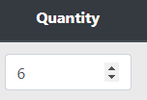**s**

Figure 4: Textbox for numeric value

Figure 5: Textbox for date value

### Dropdown list

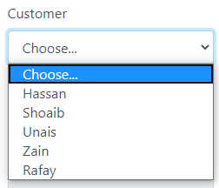

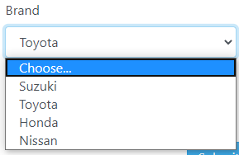

### Command button

Figure 1: Add vendor Button

Figure 2: Add row Button

Figure 3: Generate Invoice and Cancel Buttons

Figure 4: Submit and Generate Button

### Radio button

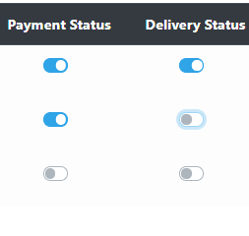

### Table or Grid

### Image

## **Element layout**

We use same control in our two interface which is use multiple time in our application as element layout



Textbox for numeric value

Textbox for date value

## **Color theme**

We use blue color theme in our application entirely.

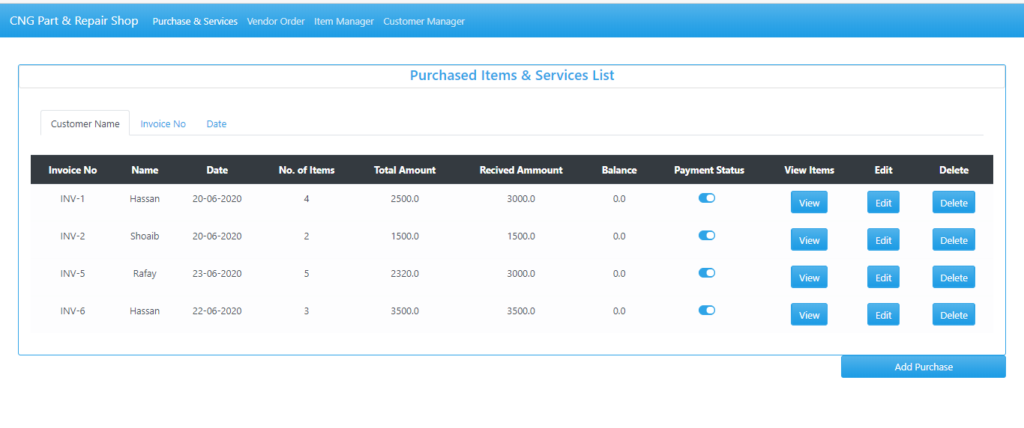

## **Alignment of text**

We use right in all our typing and selective controls.

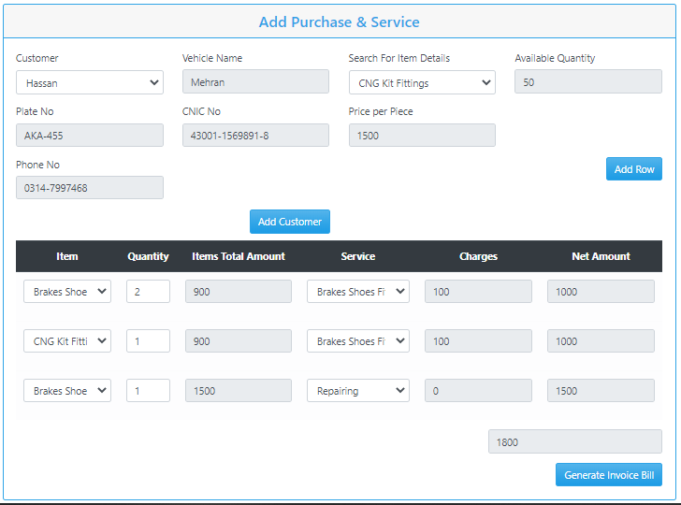

## **Element placement Style**

Through our application element placement style is left align in all interfaces.



## **Navigation Style**

Throughout our application navigation perform with navigation bars

### App navigation

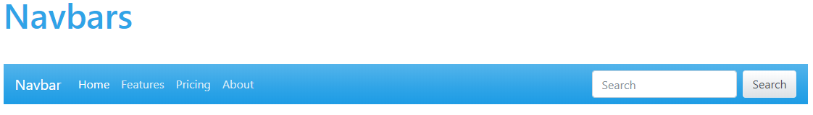

## **Feedback Style**

Our application feedback style is warning message.

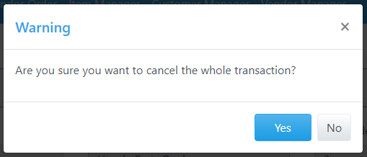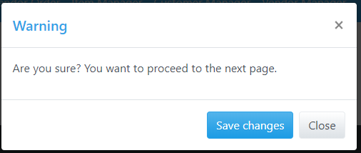

## **Support Style**

Our application support style is warning message.

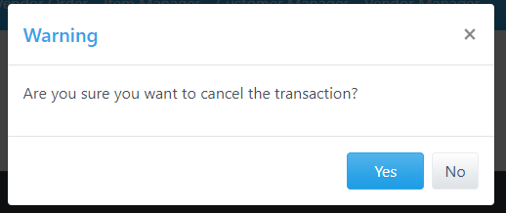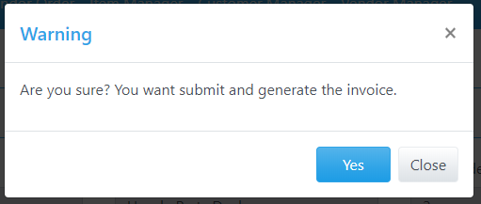

## **Mouse cursor style**

In our application we use three type of mouse cursor style

* **Normal select**

It is use in drop down and radio buttons.



* **Text selects**

It is use in all text boxes.



* **Link selects**

It is use in all command button.



## **Interface Style**

We use form-based interface style throughout our application.

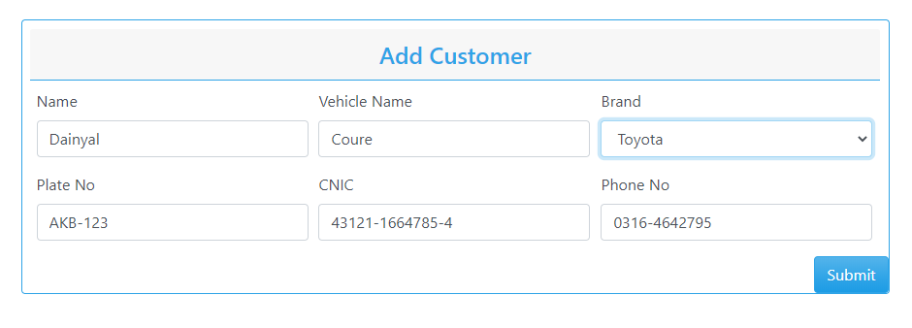

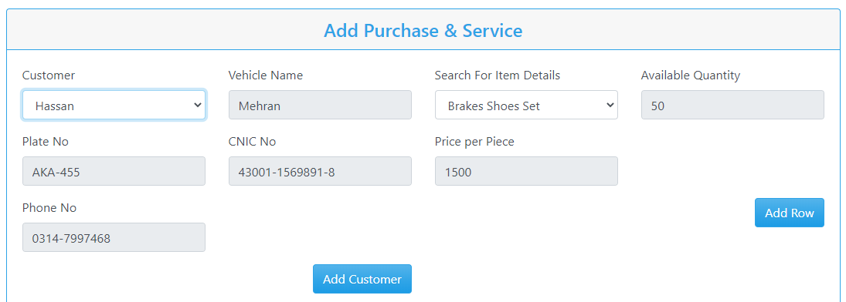

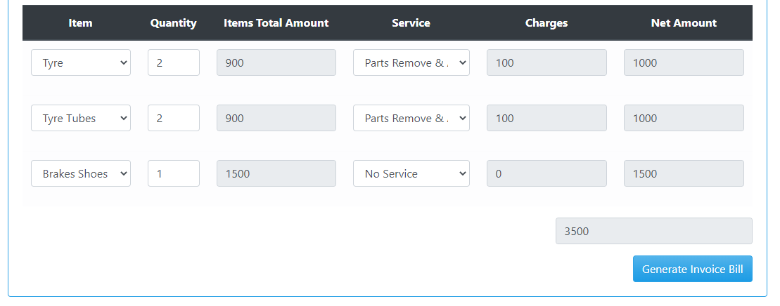

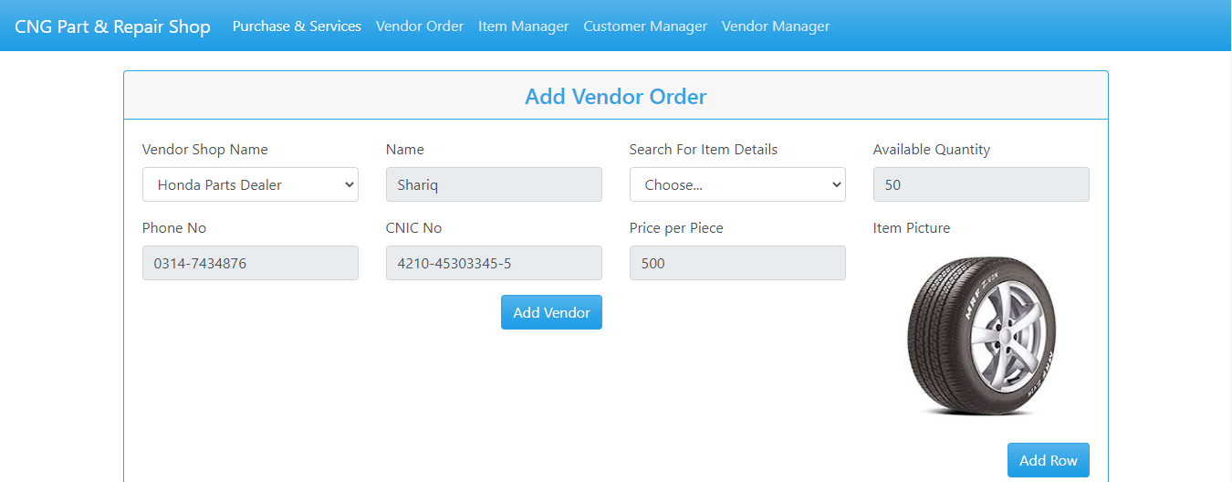

## **REQIREMENTS**

Here are the following requirements:

* Color them must be in blue color.
* Interface style must be form based.
* Elements must be left align.
* Feedback style and support style must be a warning.

**STRATEGY:**

#### **Navigation of Purchase Interface**

The application starts with the navigation on to the first page i.e. Purchase List

Now here are 2 possibilities, occur whether it selects the options from the navbar to navigate to a different web page or choose from the other four events buttons on the table first let’s see the table features;

1. **By clicking the view button**

It will show the details of the items purchased by the customer and then return to Purchase List.

1. **By clicking the edit button**

It will navigate to purchase edit page from that particular row where edit was selected to edit the details of that purchase.

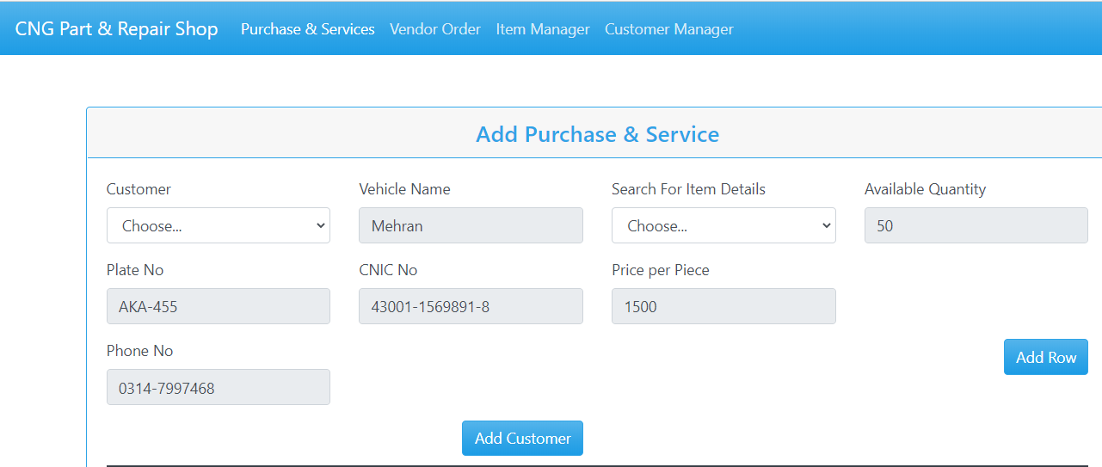



* + 1. **By clicking the add customer button:**

It will navigate to add customer page to filled the detail of the customer.



* **By clicking the submit button**

It will navigate to customer list page to show that the customer detail .

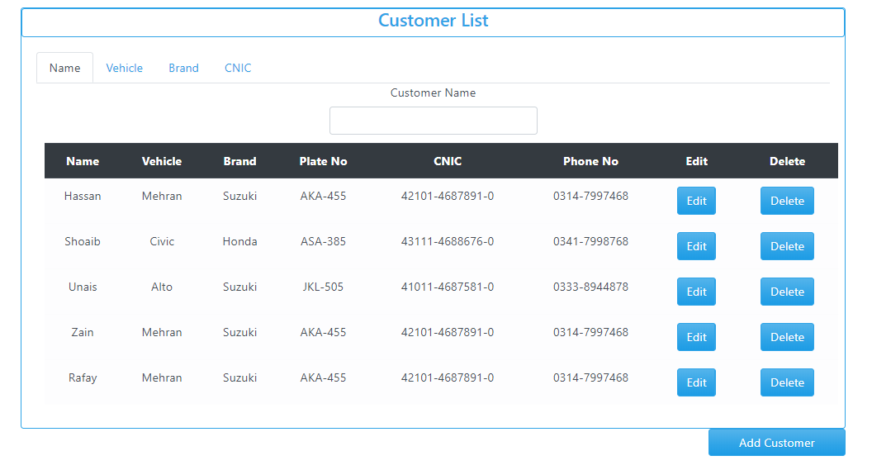

* + 1. **By clicking the Generate Invoice Bill button:**

It will navigate to invoice bill page to show that the customer detail and its order amount of their purchase.

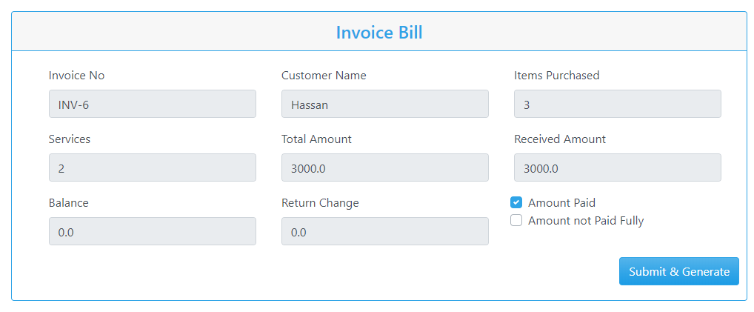

**By clicking the Submit & Generate button**

It will navigate to purchase page to show that the customer detail and its order amount of purchase.

1. **By clicking the delete button**

It will trigger the event of delete the entire row from the purchase list and navigate to purchase list to show the new list.

#### **Navigation of Vendor Order Interface**

The application then navigation on to the second page i.e. Vendor order list

Now here are 2 possibilities, occur whether it selects the options from the navbar to navigate to a different web page or choose from the other four events buttons on the table first let’s see the table features;

1. **By clicking the view button**

It will show the details of the items purchased by the vendor and then return to vendor List order.

1. **By clicking the edit button**

It will navigate to vendor edit page from that particular row where edit was selected to edit the details of that purchase.

* **By clicking the add vendor button:**

It will navigate to vendor order list page to show that vendor is added to the list.

* **By clicking the Generate Invoice Bill button:**

It will navigate to vendor invoice bill page to show that the vendor detail and its order amount.

* **By clicking the Submit & Generate button**

It will navigate to vendor order list page to show that the vendor detail and its order amount.

* **By clicking the cancel button**

It will navigate to vendor order list page to show that the vendor detail and its order amount.

1. **By clicking the delete button**

It will trigger the event of delete the entire row from the purchase list and navigate to purchase list to show the new list.

